Integrated Supply Chain and Manufacturing Order Forecasting

**DS 785 - Capstone**

**prepared by: Hassan Aluraibi**

2022

Table of Contents

**ABSTRACT** 3

**CHAPTER I: INTRODUCTION** 6

**CHAPTER II: REVIEW OF THE LITERATURE** 7

**FRAMEWORK** 8

**JD.COM** 10

**RESILIENT SUPPLY CHAINS** 12

**LEADERSHIP AND OPERATIONAL EXCELLENCE** 14

**CONCLUSION** 15

**CHAPTER III: RESEARCH METHOD – QUANTITATIVE** 16

**INTRODUCTION** 16

**RESEARCH DESIGN** 17

**RESEARCH QUESTIONS AND HYPOTHESES** 19

**POPULATION AND SAMPLE** 20

**INSTRUMENTATION** 20

**DATA COLLECTION** 20

**DATA ANALYSIS** 22

**CONCLUSION** 23

**CHAPTER IV: RESULTS** 24

**INTRODUCTION** 24

**WHY FORECASTING?** 24

**RESULTS – OPERATIONAL** 27

**RESULTS – ORGANIZATIONAL** 29

**RESULTS – ENGINEERING** 29

**CONCLUSION** 31

**REFERENCES** 35

**LIST OF TABLES AND FIGURES** 38

1) Supply Chain Resiliency Framework 38

2) JD.com supply chain structure vs. a traditional supply chain 38

3) Digital Technology List 38

4) Integration Needs 38

5) JD.com optimization model 38

6) Subset of Odoo extract from purchasing table 38

7) Data retrieve argument – Odoo 38

8) Dashboard 38

9) Odoo relational tables 38

10) Odoo GUI terms 38

11) Lab and quality holds 38

12) Odoo REST API 38

# **ABSTRACT**

Greyscale AI is a capital equipment OEM and I am a part of their supply chain team. As a startup, our resources are limited, and due to COVID, supply chains are unpredictable and lead times are notoriously misleading. This capstone project illustrates a business problem that was solved for Greyscale AI’s supply chain team using:

* Feature extraction from an ERP system (Odoo)
* Database integrations (ODBC / REST API)
* A dashboard to forecast inventory needs (aggregations and sums)
* An automated process flow (spreadsheet integration, ERP database querying)

I am not a supply chain specialist, nor do I have the professional or academic background, but I am fortunate to have been led by my boss, Josh Sokoloff, whose experience and guidance led me to develop this forecasting report that we use regularly to plan inventory. In most scenarios, our supply chain of ~100 parts would be relatively easy to manage.

However, due to COVID, even the most common of parts, can actually be driven by a deceptively strangled supply chain, presenting us with 6-8-month lead times, where they would otherwise be normally stocked and on shelves. I have spent many days, nights and even weekends struggling to source parts, substitutes or bid through brokers to ensure we have parts on hand to avoid starving our manufacturing operation.

This project exposed me to everyday problems, solvable with descriptive analytics. This project did not generate any models, or predictions (although I had initially planned to), but it did create a tool that became the main process for forecasting and procurement. We extensively rely on our ERP database (Odoo) to manage many business processes, so it was natural to integrate directly with this database, to retrieve information on dates, quantities, locations, and projected consumption of part.

This project was a bittersweet experience. It was my first real world data project, and I learned a lot. I had a hard time understanding the database schema we had on hand, and thinking about what fields we could slice/dice and roll up/down to obtain the data points that were required for our report. This to me was the most insightful part of the exercise, in how understanding your dataset and features of interest, was incredibly important for reporting. It was interesting to get this perspective from my boss Josh, who was an incredible analyst and mentored me throughout the project. We also leveraged the help of an Odoo consultant, who helped us perform some of the data integrations, namely the REST API required to query the database, and populate results directly onto the spreadsheet.

Supply chains have become a hot topic for analysts, data scientists and researchers, as pre-COVID models have proven to be somewhat ineffective in a post-COVID world (Shih. W, 2021). I’m thankful that I had an opportunity to sharpen my understanding of this fascinating field that is filled with anomalies, unpredictability, volatility, and tremendous opportunity to leverage data to optimize outcomes. Many of the world’s leading organizations have adopted new strategies against a post-covid world, and these companies and some of their applications will be explored in this paper.

Lastly, this project was scoped to meet the demands of a small startup (20 people at the time). While the demand for world class operational excellence is a major driver in all activities, the right-sizing of this project and scope was key. At the beginning, a model was set to be a deliverable, but it became clear that the most meaningful impact for Greyscale AI today, was in a descriptive analytics project. With a minimal sales history, and as a growing company, the dataset we used would not have provided any meaningful insights to predict/trend machine sales over time, and consequently determine supply chain demand. However, one strategy that was used to project demand was to generate manufacturing orders in advance (inside of our ERP), to help us forecast part consumption on a weekly basis. This enabled us to define a schedule of receipts of inbound stock, and consumption, to generate a meaningful view of our inventory. There will be images, and tables shared as well to help readers visualize aspects of this project, and the tools that were used to build this solution.

At the end of the day, this has been one of the most challenging, but oddly rewarding experiences of my academic and professional career. Developing a solution in a short time frame meant leveraging ready made tools, and finding creative ways to use the data I had on hand. The dataset is managed entirely by me (our ERP), and so it was also an opportunity to audit my own work and ensure that the data in the system was “good”.

As Greyscale AI continues to grow, I look forward to applying my data science knowledge and skills in meaningful ways, to help manage everyday business problems. This project can be considered a stepping stone for further analyses and solutions, that leverage the data stored in the ERP, for other use cases as well. Thank you for taking the time to read this paper.

# **CHAPTER I: INTRODUCTION**

Greyscale AI designs and manufactures their own X-Ray inspection machines, and I work in their supply chain department, managing their ERP system. As a result of COVID, inventory management and ensuring parts are on hand has been an incredibly challenging feat for some of the following reasons:

* Global supply chains have been disrupted due to lockdowns (regional and nation-wide)
* Warehouses are understaffed due to COVID – *delay in logistics*
* Manufacturers are understaffed due to COVID – *lack of stock, and availability*

As such, the purpose of this client-based project was to develop an integrated forecasting tool, that uses data in our Odoo ERP system, and produces a dashboard to help us project inventory needs months in advance.

Some of the questions we would like to answer through this client study include:

* When do we need parts in hand to avoid starving our manufacturing process?
* How far in advance do we need to order parts?
* What opportunities arise in cost reduction if we buy quarterly in bulk, with blank POs?

The expected significance of this study was a comprehensive, end to end supply chain forecasting tool that allows our department to communicate, plan and procure parts for our machines efficiently.

Some terms that may be used include:

* **Purchase Orders/POs:** A digital transaction, generally B2B
* **Manufacturing Orders/Mos:** A digital record of part genealogy, commonly found when combining several parts, to make a single one
* **ERP/Odoo:** A digital system consisting of many applications and services to manage a business. Includes procurement, inventory and manufacturing in particular.

The one assumption for this study was that it has been approved and vetted by management at Greyscale AI, and will be used in production upon completion (and will continue to evolve).

This study should be a fun, educational excursion, with a deliverable that provides value to my day to day work. It will enhance my ability to communicate across the organization on supply chain issues and challenges, and plan effectively.

# **CHAPTER II: REVIEW OF THE LITERATURE**

COVID 19 may have been the single most disruptive event in supply chain history. Descriptively referred to as a “*simultaneous disruption propagation in the supply chain (i.e., the ripple effect) and epidemic outbreak propagation in the population”* (Hald,Coslugeanu, 2021). This modern phenomenon has mandated supply chain professionals to pursue digital strategies to leverage modern day tools and analytics, for better predictive capabilities while bracing for the next global disaster. This literature review explores a series of journals and articles that capture a modern perspective on supply chain challenges in a post COVID world. As digitization has enabled certain industries to thrive, the main focus moving forward was how supply chains, a predominantly “analog/real world” industry (physical parts to physical places), can leverage modern tools (data and analytics) to plan, predict and manage more effectively. One example was JD.com, an e-commerce company in China, that maximized sales while others dwindled, partly attributed to their sophisticated data driven infrastructure (Shen, Sun, 2021). This example, and other essential tools will be covered in this research paper, including a short-list of 3 key areas of focus for supply chain professionals to hone in on including:

* Digitization
* Integration
* Operational Excellence

The articles selected were based on a few criteria including:

* **Date**: 4 out of 6 articles referenced were sourced from post-covid publications (2019 onwards), as the focus of this review was on the implications of COVID 19 on supply chains
* **Data:** Each article focuses on the importance of data applications to enable visibility for supply chain professionals
* **Practical:** As this was a review based on a company capstone project (for my employer, Greyscale AI), a lot of the content was either directly applicable (ERP / system design) or roadmap friendly (framework for supply chain resilience)

## **FRAMEWORK**

A framework was established by Magableh (below) to define a short, medium and long term approach for organizations currently dealing with supply chain disruptions during COVID, to plan and prepare effectively for a future pandemic (Magableh, 2021). The impetus of this strategy was in line with Hald, and Coslugeanu, who suggest that companies need to adopt a series of stages developing “resilience-driven” solutions, that continue to enhance their supply chains ability to deal with disruption, as a result of inevitable challenges (rapid supply chain disruption, material shortage, global shut down) (Hald, Coslugeanu, 2021).

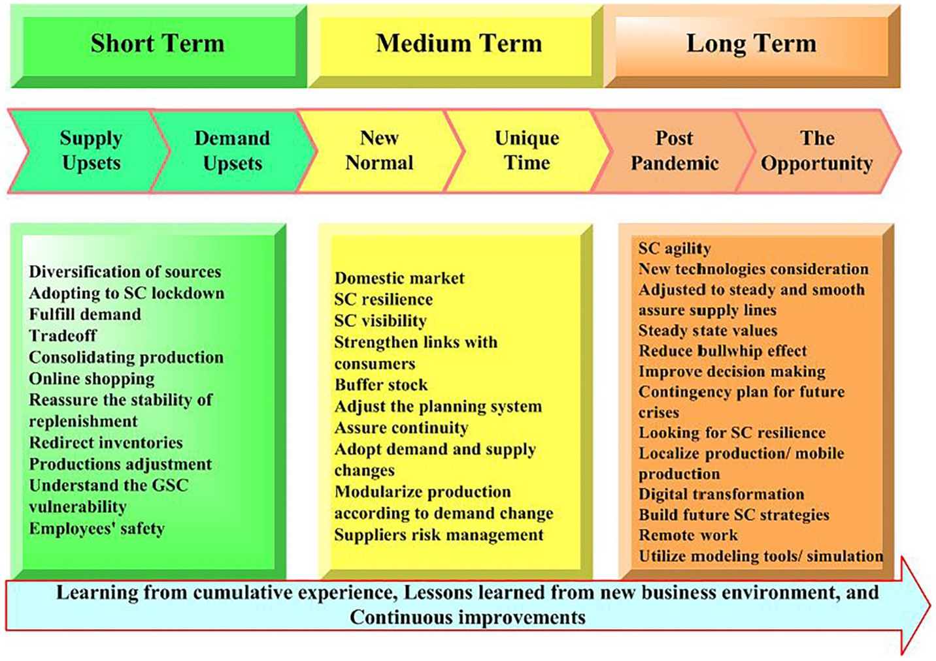

Figure 1 Supply Chain Resiliency Framework (Magableh, 2021)

The main takeaway from Magableh’s framework, was optimistic. She states: “*Delivery and distribution faced several challenges, including direct distribution difficulties, increased online orders, re-staffing of distribution centres (DCs) and warehouses (WHs)….. Thus, the pandemic proved to be an opportunity for online stores and businesses*” (Magableh, 2021). As such, her antidote to supply chain disruptions was a healthy dose of digital panacea in the form of integrated, real time systems.

One of the most difficult aspects of supply chain management during COVID 19, were the challenges that required an interdisciplinary team to resolve (Magableh, 2021). These types of challenges caused natural slowdowns in organizational bureaucracy and throttled their agility, exposing those without the proper infrastructure with an inability to continue service. What was apparent now, more than ever, was that the tools for everyday professionals are more accessible and easier to use than ever, to apply modern techniques to supply chain problems. Deep learning has proved to be incredible effective at dealing with supply chain datasets that have a necessary, but high dimensionality (Vandeput, 2021). The tools follow a standard recipe of implementation, that relies on integration, which was arguably the most important technical challenge that exists in supply chain digitization today (Ganesh, Shanil, et. al, 2016). Some of these tools are easy to use, off-the-shelf packages as found in Python’s scipy stats, however others are more comprehensive packages like Odoo’s ERP system (Ganesh, Shanil, et. al 2016). These types of scalable tools represent the digital wave of technologies that has enabled certain supply chains to thrive during COVID, allowing them to leverage the cloud, big data, and analytics, to continual update models as lockdowns were lifted/adjusted.

## **JD.COM**

One example from the literature was drawn from JD.com, a Chinese e-commerce service provider that experienced record growth throughout COVID 19, partially attributed to their modern data infrastructure and digitization strategies (Shen, Sun, 2021). When COVID 19 hit, it was apparent that the companies that had adopted a “digital first” strategy, were more agile than their counterparts (Shen, Sun, 2021). The interesting aspect of JD.com’s strategy was that beyond their significant digital infrastructure that will be explored a little further along, it was necessary to understand how they differ operationally than standard ecommerce distributors in the market today.

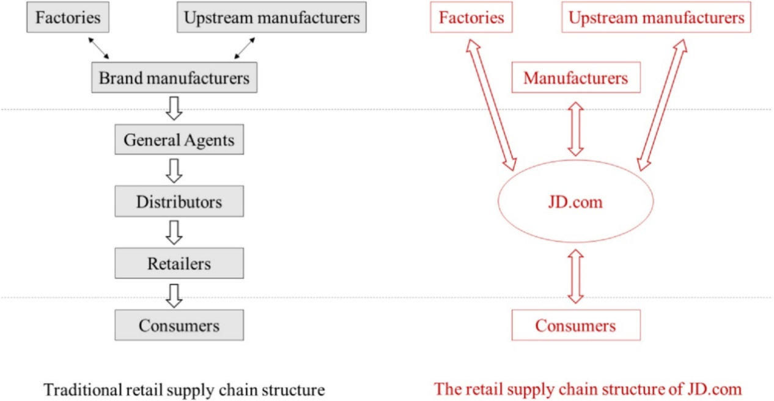

Figure 2 JD.Com supply chain structure vs traditional

According to Shen and Sun, “*To summarize, the integrated supply chain structure of JD.com ensures higher levels of collaboration, information sharing, and agility and results in better supply chain resilience than those of other firms.” (*Shen, Sun, 2021). While there was a need for distributed channels to exist, and how important they are to global logistics, it was clear that in the case of a global supply chain pandemic, an organization will benefit from having control over their distribution channel. This level of vertical-integration, facilitated JD.com’s digital first strategy to manage their deliveries and logistics more efficiently and effectively, than typical 3PL models that were dependent on an externally prioritized supply chain (Shen, Sun, 2021).

Furthermore, the case for digitization continues as JD.com adopted an intelligent forecast platform that was able to forecast new product arrivals without prior history, where machine learning was leveraged to learn from the purchase cycles of similar products in their catalogue (Shen, Sun, 2021). This level of supply chain diligence built into their end to end infrastructure inspired JD.com to develop indicators based on supply chain resilience (Shen, Sun, 2021). This aspect of resilience was also acknowledged by Magableh, who suggests a strategy of “capacity building”, to withstand inevitable supply chain catastrophes (Magableh, 2021). Capacity building was a metric that seeks to ensure a company has a projected forecast of supply chain contingencies, in the event of an extended shutdown.

This example was elaborated on by Shen, Sun, as JD.com’s vertical supply chain, coupled with their digital first infrastructure, enabled them to forecast months ahead with the use of advanced analytics and neural networks, to procure volume in advance from upstream supplier, operate with agility in their supply chain (Shen, Sun 2021).

## **RESILIENT SUPPLY CHAINS**

There are many aspects of COVID 19 supply chain responses that have captured the attention of companies and organizations, and as asked in Hald, Coslugeanu, "How are digital technologies proposed as part of resilience-driven solutions to the future operation of global supply chains?” (Hald, Coslugeanu, 2021). This last section will cover 3 key elements of a successful, digital supply chain strategy, including:

* Digitization Tools (IoT, Sensors, Data Collection)
* Integration
* Operational Excellence

Beginning with digitization tools, as explored in Estefania, Samir et. all, ERP systems are the standard type of industrial business system, used on a global scale worldwide (Estefania, Samir, et. al, 2021). Although there are many types of ERP systems and the definition of what makes an ERP was evolving, in general it comes to down to a multi-layered system that has services that can interact with one another. From inventory receipts of a physical item on the production floor, to a roll up of an entire facilities on-hand inventory (and subsequent liability costs), the systems have for years enabled companies to view their organization through a digital lens.

Modern supply chains are now incorporating IoT devices, and aggregating data to the cloud, as seen in IoT enabled production lines that offered remote visibility, experienced less downtime during stringent COVID lockdown measures (Hald, Coslugeanu, 2021). The trend of new tools and technologies are enabling a more regionalized approach to supply chain management. However, historically ERP systems have acted as a belt-buckle, tightening the waists of operations and their P&L, enabling finance to asses a value across an entire operation in a few rolled up metrics. Nowadays, this lean manufacturing approach was being challenged, as inventory on hand was essential during a supply chain pandemic, contradicting traditional cash flow strategies (Hald, Coslugeanu, 2021). Therefore, a combination of capacity building and digital tools like IoT and 3D printing, represent a series of tools that are capable of deployment in a contingency planning model. An example of some of these technologies can be seen in the list below.

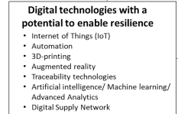

Figure Digital technology list (Hald, Coslugeanu, 2021)

The second essential element to evaluate was integration. As a topic of significant discussion in Estefania, Samir et. al, 46% of companies surveyed (23/50 respondents seen below) (Estefania, Samir, et. al 2021) said that the main focus of their integration efforts was system to system. The data silo was a real world problem, which illustrates the evolution of proper data strategies an organization goes through over time (Estefania, Samir, et.al 2021).

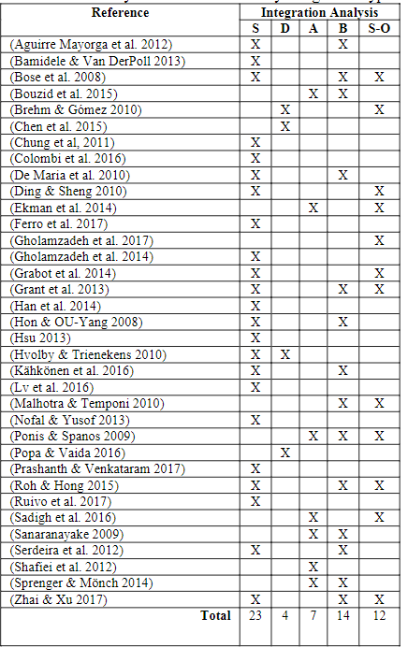

Figure Integration needs - 50 respondents (Estefania, Samir, et. al, 2021)

As such, integration was a major area of focus for supply chain initiatives, as they try to aggregate data from many systems into a single source of truth. The benefit of those that adopted a scalable system, like Odoo’s ERP, was that as market demands evolve, so do the tools at their disposal (Ganesh, Shanil, 2016). Odoo continues to provide updates across a variety of apps and services, enabling companies to scale the tool for everything from inventory management, to manufacturing operations (Ganesh, Shanil, 2016). They attribute Odoo’s ability to integrate and scale to its (Ganesh, Shanil, 2016):

* Flexibility: Can be integrated with many other tools, open source python APIs available
* Absolute Ownership: Less dependencies on vendor integrations
* Quality Assurance: Independent developer community continues to evolve toolset
* Easily upgradeable
  + Python API
  + Postgres (back end DB)

The importance placed on a modern tech stack continues to be a prevailing theme for the tools that enable a digital supply chain.

## **LEADERSHIP AND OPERATIONAL EXCELLENCE**

Lastly, although the focus of this review was on digital technologies and tools, emphasis needs to be placed on effective leadership and operational excellence being in place, or quickly assembled to ensure continuity and sustainability of these new digital transformation initiatives (Shen, Sun, 2021). A digital first strategy as seen in JD.com’s example, was only actualized due to the action oriented leadership team, the foresaw the inevitable challenges of COVID-19, and made the investments to develop the tools to mitigate, and in their case, thrive (Shen, Sun, 2021).

Operational excellence was the underlying framework of Magableh’s framework on supply chain resiliency. As an interdisciplinary problem, it requires skills and tools that can actually extend beyond domains, which was another element contributing to the growth of ERPs like Odoo (Ganesh, Shanil, 2016). If a single system can house data used across an entire organization, a ground truth can be established with alignment across many departments. If procurement can understand the contingencies required in manufacturing, they can proactively order, and predict potential pinch points in the supply chain. The purpose was for data and digitization to empower supply chain professionals worldwide. For example, seen below was a logistics model trained with JD.com’s intelligent platform, and the optimizations it was able to identify. These insights can only be derived when a complete dataset was accessible, with as many relevant features to model the problem as possible.

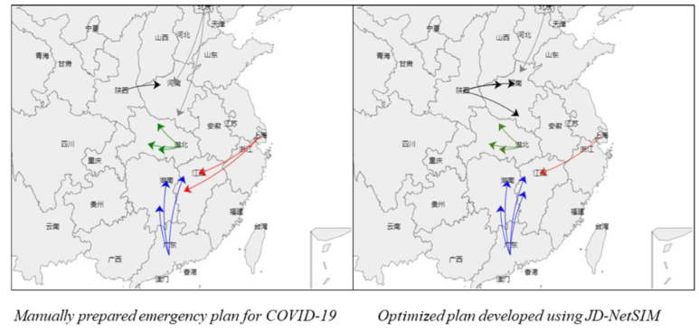

Figure 5 JD.com optimization model

## **CONCLUSION**

The focus of this literature review was to get a finger on the pulse of the overarching supply chain challenges that have emerged as a result of COVID 19, and the expectation for supply chains to transform their processes and operations moving forward. From disruptions in the air (flights cancelled), across borders (lockdowns), and on routes worldwide (COVID testing requirements), COVID 19 has presented a myriad of problems for supply chain professionals to manage (Hald, Coslugeanu, 2021). The means to handle modern problems, was to use modern tools, and there were several case studies and examples of organizations that led with a data first strategy, digitization and integration in mind, to generate the best outcomes for their customers, who are dependent on their products and services.

Disruption was the new norm, and whether it’s IoT enabled factory lines, or neural networks, there are numerous examples of how digitization protected and enabled supply chains to continue operating, during an unprecedented global pandemic. It was likely that frameworks such as Magableh’s, will become standard slide-ware within supply chain exec overviews, ensuring steps are taken immediately to map out near and long term plans for future resilience (Magableh, 2021).

Therefore, supply chains have become a hot bed of focus for technology and digital disruption, and tools like ERPs, cloud technology, and data applications, may be the difference between a thriving operation, and one on the brink of collapse when the next pandemic, inevitably occurs.

# **CHAPTER III: RESEARCH METHOD – QUANTITATIVE**

## **INTRODUCTION**

The benefit of my client-study capstone project was that the dataset was preloaded, normalized and structured in relational tables in Greyscale AI’s Odoo ERP system. This allowed me to focus on the problem at hand, and what fields were most relevant to forecast inventory, as opposed to data cleaning.

The issue at hand was that as a startup, Greyscale AI has to be sensitive about cash flow, but obsessed with customer satisfaction. Timelines are absolutely critical to ensuring we maintain a competitive edge in deploying new technologies in the food inspection industry. As a result of COVID, came the most turbulent supply chain disruption in history, straining Greyscale AI’s ability to get the right parts, to the right people, at the right time.

Furthering our challenge, we also have to deal with an evolving product, and a BOM (bill of materials) that was constantly changing, forcing us to scramble and procure alternatives in COVID stricken markets

Therefore, led by my boss, Josh Sokoloff, we undertook the challenge of defining, developing and deploying a report for forecasting inventory.

## **RESEARCH DESIGN**

The main challenge in defining our problem statement was determining how to technically forecast inventory using Odoo. As a startup, our data and data modelling isn’t mature. Teams in different departments have their own formats for reporting. Therefore, we used the data we had on hand across:

* Manufacturing and production schedules
* Sales and Customer Forecasting
* Supply Chain Lead Times

to generate a comprehensive forecast.

To begin, we defined our inventory into three categories:

* **Critical** Parts that have a high dollar value and lead time
* **Min – Max** Parts that we need to procure, but not forecast
* **Kanban** Parts that don’t need traceability (screws, nuts, washers, wire etc.)

For the purposes of our report, we felt that it was necessary to focus on parts that we defined as critical. We audited our inventory and generated a subset list of parts defined as critical (based on dollar value, and lead times).

Without an actual production schedule, we had to model one ourselves based on the following considerations:

* Manufacturing can produce up to 2 machines per week
* Sales has projected 100 machines sold by year end
* Parts must be in stock prior to manufacturing and have lead significant lead times

In Odoo we have access to the following data tables:

* **Procurement**  *Receipt dates* from purchase orders for scheduling of part restock
* **Manufacturing** *Schedules the consumption of parts* based on a pre-defined BOM
* 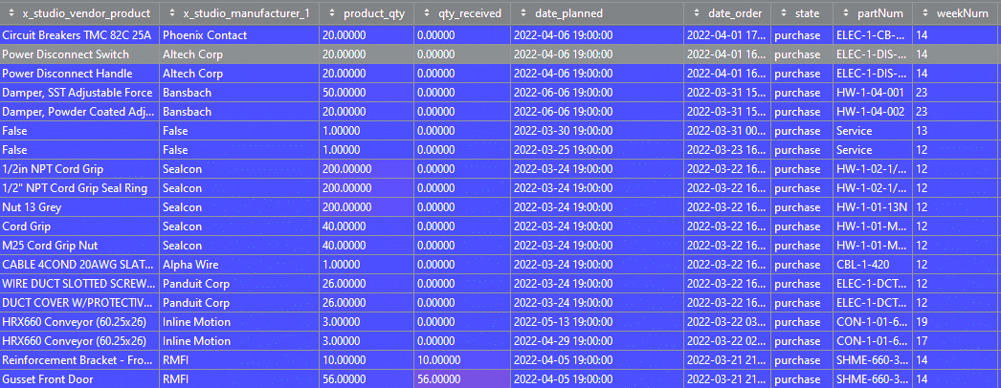**Inventory** *On hand part count*, by unique part #, traceability and availability

Figure 6 Subset of Odoo extract from Purchasing Table (includes receipt date) – pycharm data view

Our goal was to define a formula (based on the data in these tables), and develop a forecast.

## **RESEARCH QUESTIONS AND HYPOTHESES**

Our objective, and question to answer, was how can we use the data inside of our Odoo ERP system, to generate a real-time parts forecast report. Odoo has many automated processes, but all data was manually entered (mainly by me today). As such, the thought was to combine:

* Expected manufacturing dates (and BOM qty. to consume)
* Expected receipt dates for inventory
* Active inventory counts

to generate a weekly formula. We initially thought of a monthly view, but then agreed on projecting inventory week to week.

This formula was shown and defined below:

**Manufacturing Orders (PL**) **SUM**(fromMfgTbl, *partName*, *partMfr*, *mfgDate*)

**Reserved Inventory (RV)**  **SUM**(fromRsrvTbl, *partName*, *partMfr*, *rsrvdDate*)

**Parts Receipt Dates (PO)**  **SUM**(fromRcptTbl, *partName*, *partMfr*, *rcvdDate*)

**Available Inventory (IN)** = PO + RV – PL

The hypothesis was that by implementing a real time report, and extracting the data above, we will be able to effectively plan inventory, and avoid a scenario of stocking out.

## **POPULATION AND SAMPLE**

For this project, there was no need to sample the data, as all of the features required (part #s, purchase, receipt dates) were readily available in our ERP. Extraneous data, like manufacturing orders, are manually generated (stored in Odoo).

A filter was used to only extract data that fell within the forecasting window that we desired (e.g. 03/31/22 – 10/31/22)

## **INSTRUMENTATION**

With thanks to my manager Josh Sokoloff, the decision to adopt an ERP system to manage the required business processes, meant that all of the data we required was readily available to be queried. Odoo was a made up of many ERP modules that manage forms/input fields across many processes an organization may have (quality, helpdesk, project mgmt.., manufacturing, inventory, e-commerce, etc.). It was not ready for analysis, and this will be discussed further in the next step.

## **DATA COLLECTION**

Several queries were written to extract data from Odoo using excel macros, populating them into an excel based spreadsheet. These queries were based on a standard Odoo SQL template, with adjustments based on our desired table and columns to query. To provide us with the most functionality, we decided to adopt a manual, cell trigger to update our dashboard, and a daily (6AM) automated trigger. This ensures a regular interval of data freshness, and also the ability to get real time data updates, or to troubleshoot modifications to the script.

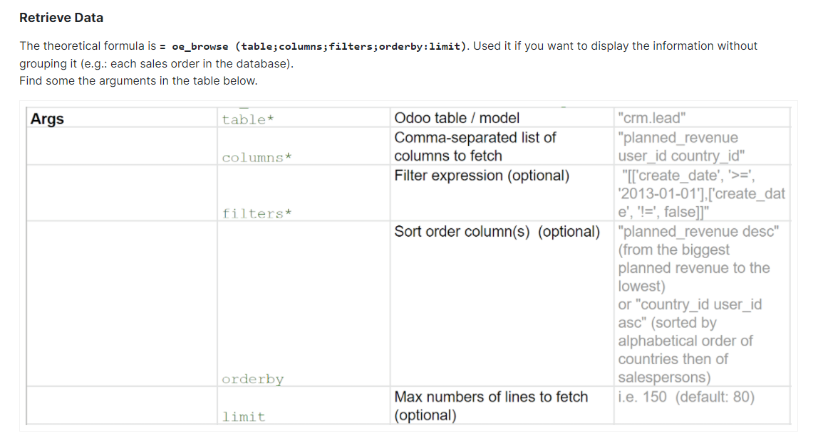

Figure 7 This was the retrieve data argument structure to query data from Odoo (function - oe_browse)

Data was then ingested into a python script for automated cleaning and filter, using a series of transformations (mainly through pandas). A comprehensive end to end python script was written to:

* Query odoo and extract 3 tables (Manufacturing / Inventory / Receipts)
* Read these tables into python as pandas dataframes
* Subset and clean all 3 data frames, leaving only the relevant features for this analysis
* Export as completed spreadsheet

Time and dates were also converted, adapting date/times into a week # of the year (to simplify for weekly reporting requirements)

Figure Argument to extract isocalendar week of the year (e.g. 1 for week of Jan 1st.), converting queried date/time format

weekNumList.append(datetime.datetime.strptime(item,'%Y-%m-%d %H:%M:%S').isocalendar()[1])

## **DATA ANALYSIS**

The objective to create a real time dashboard based on automated ERP extracts, was completed in an excel spreadsheet. After cleaning and formatting of the Odoo extracts, the data was arranged into a week-to-week view of projected inventory.

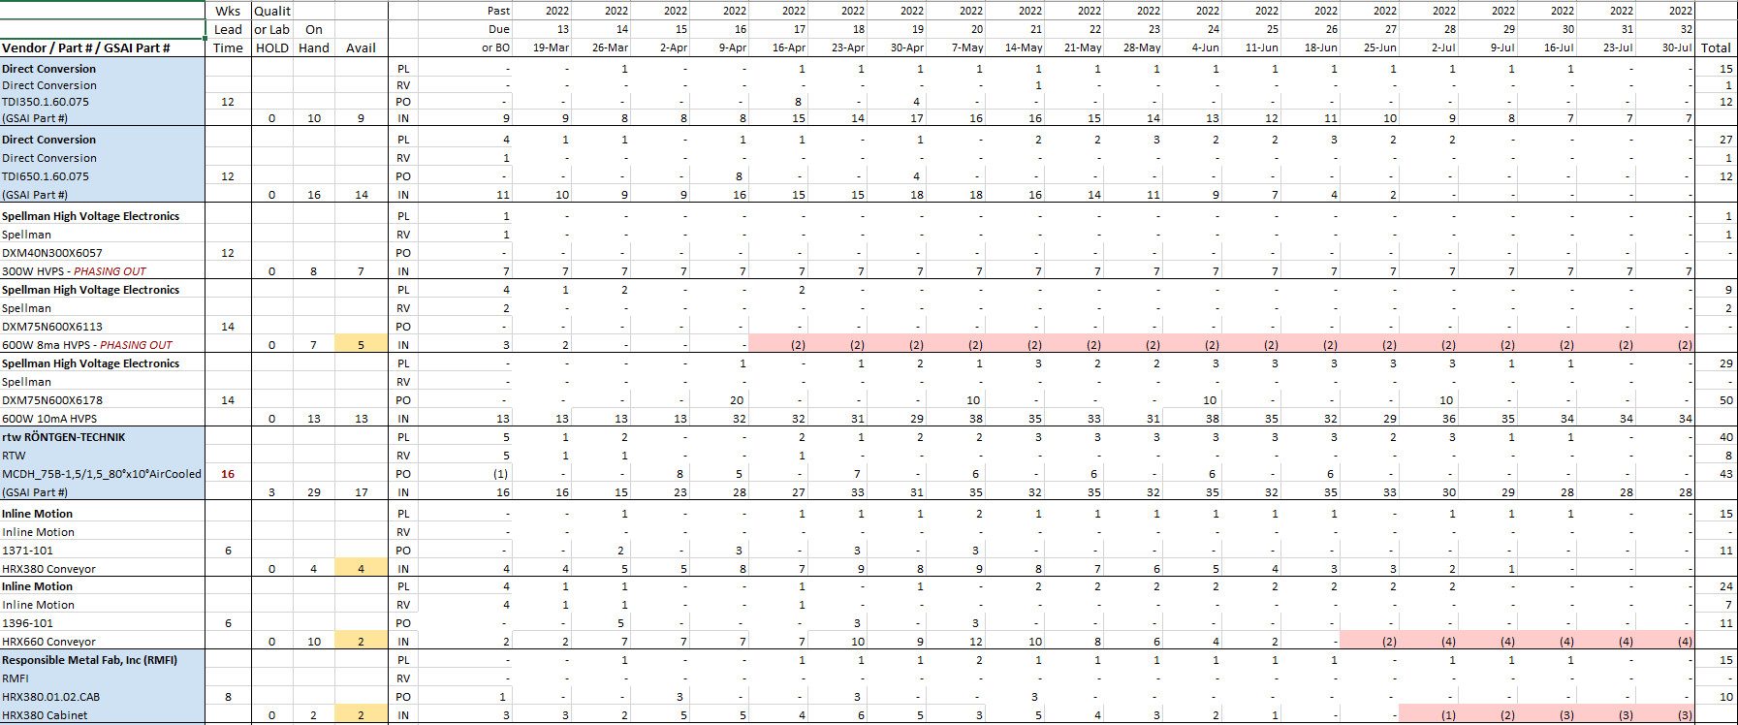

Conclusio

Figure 8 Snapshot of subset of critical parts from dashboard. Part details on left, quantities on right.

This can be seen with the image above as the cells highlighted in:

* **Orange** Timeline (in weeks)
* **Blue** Summed values (by row)
  + PL Planned
  + RV Reserved
  + PO Purchase Order
  + IN Inventory (formula)
* **Red** Unique Part details

Aggregating data across these cells, on a weekly view, enables us to visualize our supply chain forecast for a single part. Duplicating these cells, and updating the part # and manufacturer, automatically extracts row to create the same view for a different part.

By having this dashboard view, we were able to successfully forecast our inventory counts to ensure that we have enough inventory to fulfill machine orders. I used a conditional format to highlight cells in **red**, that were <0, to draw attention for remedy and further analysis.

This end to end report has given us an incredible amount of analytical power in now being able to:

* Forecast inventory dynamically, by scheduling manufacturing orders
* Present a supply chain estimate to finance to project cash flow needs
* Ensure we have enough stock on hand to avoid shortages
* Visually communicate our supply chain story to management

## **CONCLUSION**

Greyscale AI’s Odoo consultant remarked that this was one of the most sophisticated reporting extracts they have ever seen. While the idea may not have been mine, the feature definition, extracting, data prep, testing and debugging were a substantial technical and business logic undertaking. The hypothesis that we could marry 3 different tables to give us a projected forecast view was validated and verified with the dashboard.

# **CHAPTER IV: RESULTS**

## **INTRODUCTION**

I have eagerly awaited this update, as I will reveal findings and share results. As I will further explain in this section, the:

* Implementation of an ERP System (Startup – Day 1 Decision)
* Management of business processes with an ERP (procurement / inventory / manufacturing)
* Identified need to develop a tool to forecast
* Integration of several systems (Odoo / Sheets / Python)

led to a successful deployment of a data driven forecasting tool for my employer, Greyscale AI.

The following, was a thorough summary of the challenges, areas for improvement and meaningful successes that I have personally experienced throughout this Capstone project, including feedback from stakeholders in my organization.

## **WHY FORECASTING?**

It’s always difficult to develop tools. Particularly ones that are very specific to a business’ needs. As a small startup, Greyscale needed a means to forecast the materials required to manufacture their X-Ray inspection systems. An Odoo (ERP) consultant was involved in the evaluation phase, showcasing solutions that the ERP system provided out of the box, to try and provide this level of functionality. However, none of the solutions seemed simple enough, and required several layers of integration that Greyscale AI as a startup did not have the resources to manage. This led to the hypothesis that a custom developed analytics tool, could help us manage our forecasting needs, and automate an otherwise grueling reporting process.

Therefore, a data discovery was conducted to identify the necessary fields to generate our forecast report schema. As this was a forecast, the natural x-axis was time, allowing Greyscale to forecast material needs, months in advance, on a week to week basis. All fields required for this report were readily available in either the inventory, manufacturing, or purchasing application databases in Odoo. A simplified ER diagram and some relevant fields shown below.

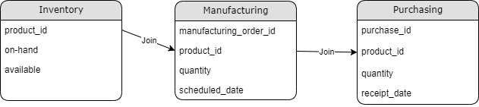

Figure 9 Relational Tables In Odoo Aggregated For Part Forecasting

By understanding the schemas in Odoo, it became clear that the key to success for this project, was to properly identify the right fields in Odoo to generate Greyscale’s report. Odoo conveniently provides a tooltip that indicates which model (table) the selected field was stored in, allow me to easily find and query it (see below). This ability to seamlessly navigate through our entire database, using a user friendly GUI, was the single-largest time saving process across this entire Capstone. I have a deep amount of gratitude that I could lever an ERP system which simplified my data gathering stage. As noted by Chau. Et Al., an IT system (such as an ERP) was integral to a successful supply chain (Chau et al., 2021).

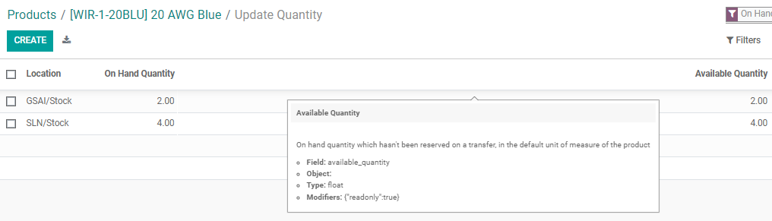

Figure 10 By hovering your cursor over a field on the Odoo GUI - Odoo presents you with important identifiers to help you extract that field for reporting / analysis purposes.

There were several instances during our ramp period (Oct – Dec) where we aggressively engaged our supply chain partners and vendors, and in some cases, sourced through brokers and 3rd parties to meet deadlines for equipment deliveries. There were several instances where we personally faced, noted by Rajesh, a single component shortage that threatened to halt our entire operation (Rajesh, 2018). We had several critical components with long lead times that were required to complete a machine build.

This challenging experience, led to the foresight and kick off of the definition, development and deployment of a google sheets based supply chain tool, that I developed under the guidance of my boss Josh Sokoloff along with an Odoo consultant. This reporting tool was designed to:

1. Forecast long lead time items (8+ weeks) across all inventory stages
   1. Quantity on order
   2. Quantity on hand
   3. Quantity in WIP (undergoing assembly)
2. Automate (to a degree) the procurement cycle
3. Instill a sense of data governance, by forcing Greyscale to rely on the data in Odoo, and update it if incorrect
4. Allow supply chain to lead by forecasting, enabling Greyscale AI to be proactive with part procurement, even when BOMs aren’t finalized

Of these requirements, their results and findings are all complete, however, item #3 was an ongoing process that was thankfully gaining momentum as well.

## **RESULTS – OPERATIONAL**

This tool was developed with the intention of improving the procurement process. An analytics tool was suggested as a means to visualize inventory on hand, to help the Greyscale AI supply chain team order proactively.

With thanks to this tool, the overall turnaround time to generate a quarterly forecast was reduced from 8 hours / month, to 30 min / week. Previously, 2 hours per week would be dedicated to modifying CSV extracts from Odoo manually, and joining data across 3 spreadsheets manually. It was cumbersome, prone to error, and frustrating. The below represents an operational achievement that focused on resolving the existing issues of Greyscale AI’s supply chain including:

* Forecasting parts as a small startup during the worst supply chain crises in recorded history
* Forecasting parts with long lead times on an ever-changing BOM

When multinationals procure and supply, they have extensive leverage and reach, and this has resulted in extreme purchasing patterns, identified by Ulutas and Karakus, which caused rapid inflation as supplies thinned, and demand skyrocketed throughout COVID (ULUTAŞ & KARAKUŞ, 2021). Over the past 8 months, electronics components across the board have been increasingly difficult to source, and as a small startup with thin pockets, we can’t compete with the juggernaut purchasing power of multi-national corporations.

However, with the help of a forecasting tool, we could now engage with our vendors in a much more organized and structured way. Our ability to communicate and forecast with this tool, has allowed us to actually lead with inventory, building up stock (approximately 20% contingency), and enabling us to perform at a highly effective operational level.

Beyond that, an added benefit of the tool was the added traceability for parts in inventory (on-hand), but undergoing repair or RMA (unavailable for manufacturing needs). This can be seen in the image below, as a quality / lab hold. According to research conducted by Ma, enhancing traceability across a supply chain was arguably the most important objective for any organization (Ma et al., 2018). This feature also opened up several easy updates to include other warehouses and locations as Greyscale continues to scale and evolve.

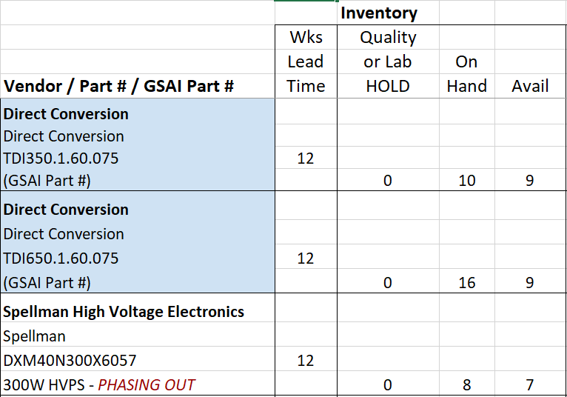

Figure 11 Added fields for quality/lab holds - part locations are virtualized, and transferred from location to location

## **RESULTS – ORGANIZATIONAL**

Our finance department requested a forecast of part orders to plan accordingly, but manufacturing had yet to release a build schedule (and confirm orders). As a startup, these gaps are always going to appear, and one added benefit of this tool was that it enabled the supply chain organization to lead with data, aggregated across other departments (mfg., procurement, finance). At its core, this tool helped supply chain justify procurement cycles, by visualizing potential stock-out dates, driven by manufacturing. A red cell conditional format was used to color a cell if it was 0, or negative.

This has helped the Greyscale AI supply chain team forecast based on a single source of truth (the spreadsheet). These trends are also explored with the knowledge sharing mantra discussed by Dhaigude et al, where Supply Chain Integration (SCI – modern data tools for visibility and forecasting), was identified as a key driver of Supply Chain Performance (SCP) (Dhaigude et al., 2021).

## **RESULTS – ENGINEERING**

Although I did not complete the entire analysis in python as I had initially hoped to, the quality of the overall deliverable was not compromised. Spreadsheet tools tend to be looked down upon by the data science community, as modern development tools like python and R, along with open source libraries, have reigned supreme for big data, real-time, and machine learning. However, right sizing a project was important, and also helps an organization like ours grow. As this Capstone was focused on a relatively small (<15K rows) relational dataset, a spreadsheet integration was ideal for where we are as a company at this time. In the future, I look forward to continuing to enhance my skillset, and grow more tools for the organization through programmable scripts, real-time dashboards, and end to end integration.

That being said, thankfully Greyscale AI’s engineering footprint for this project was small, allowing us to identify the key building blocks to build out a functional dashboard relatively quickly. A variety of functions in google sheets were used to sum, divide and aggregate values across products and time. The most challenging engineering effort was scripting the API that communicated with the Odoo database (developed by a 3rd party consultant), and identifying the fields necessary to slice and dice our database and extract the insights needed. A snippet of the API can be seen below, following a common REST API architecture, to post a user’s information (not shown) to the Odoo database, authenticate credentials, and provide access to query the database and pull the requested tables.

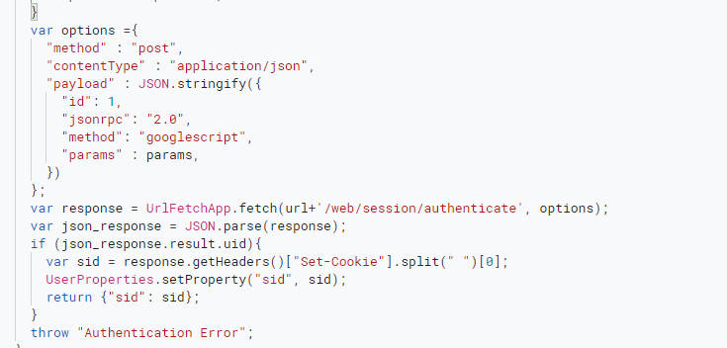

Figure 12 REST API for Odoo to google sheets integration

**RESULTS – ANALYSIS**

As a descriptive analytics Capstone, the result of my efforts concluded with the visualization of the merged Odoo data marts, aggregated over date/time. Some of the analytics considerations for our visualization included:

* Standardizing 20 week forecasts (requires manual update)
* Calculating inventory based on the formula shared in section 3
* Using conditional formats to highlight cells based on values

Although this capstone did not require predictions, or modelling, it did require a solid understanding of Odoo’s applications and database structure, and a clear business problem to be solved. Forecasting was a common data application, and under the tutelage of my boss, Josh Sokoloff, I fortunately received a crash course in supply chain management, stock rules, and reordering strategies.

There are several next steps to evaluate for this Capstone including:

* Python integration of the dataframes I transformed / cleaned, to a powerBI visualization
* Confidence intervals to predict upper/lower band outcomes

Due to time constraints, it was agreed upon by my boss Josh Sokoloff that we should focus on the descriptive elements of this project, and plan to integrate predictive features in 6 months or so as we currently:

* Lack a meaningful procurement history (COVID stricken, inconsistent lead times) and relevant data to create a model
* Produce capital equipment and are highly customer focused, so it’s more important for us to have machines ready to ship, than worrying about excess stock and cash flow issues (20% +/- was our average over-run stock rate)

## **CONCLUSION**

The forecasting tool delivered by this capstone project has enhanced our supply chain operation significantly, providing us with a world class scalable toolset, based on a highly automated ERP system, with a descriptive analytics front end. This combination of a scalable database built on business processes (manufacturing, inventory, purchase), was identified by Pisz, as a key component (Process, System) to a scalable, system design approach to solving modern, manufacturing problems (like COVID) (PISZ, 2021).

As such, a visualization with summary statistics, was ideal for this Capstone. Although Greyscale was still in its infancy, as noted by Lindquist & de Haas, tools like Digital Twins, using process data to generate scenarios and simulations, there was a lot of room for growth in how Greyscale AI manages its supply chain moving forward (Lindquist & de Haas, 2021). It was easier to build up a greenfield operation (as a startup), rather than a brownfield one that has historical systems, data siloes, and bureaucratic red tape (as commonly found in F500 organizations).

This Capstone has helped me to build confidence around my ability to manage our supply chain and in turn has also inspired me to continue building upon this tool including:

* Completing a python data integration and output to PowerBI
* Matching inventory to BOM quantities to understand how many machines we can build with the inventory on hand
* Incorporating the same logic to help forecast sheet metal and min / max parts

Supply chains continue to be a struggle to manage, but there is no better use of data in the manufacturing sector today, than in visualizing, projecting and managing supply chains. As time goes on I would also like to explore opportunities to incorporate optimization tools, forecasting and more predictive/prescriptive analyses as our historical data accrues over time. A major part of my learning curve at Greyscale AI is that I did not come from a traditional supply chain background. As an industrial automation specialist, I understood many of the leading systems and technologies that drove manufacturing on the production floor. What I lacked, was an understanding on how everything on the production floor was orchestrated. Materials are procured, stored in inventory, manufacturing orders are generated to consume materials against BOMs. It’s a fascinating string of production processes that are woven together to manufacture a machine. I had a hard time understanding what an ERP system was, or how it even worked, but as a graduating Data Scientist, I look at these systems in my domain (manufacturing) as essential building blocks for scalable, data driven manufacturing.

There has been a tremendous amount of learning throughout this process. Not having supply chain experience and being thrust into the middle of a supply chain crises, was a humbling, but difficult

experience. Frankly, without our ERP system, it would have been nearly impossible to perform all the related processes required to manage our supply chain, especially with all of the built in tools to help manage our data. It was challenging to do this Capstone project on a startup selling capital equipment, because our BOM changed regularly, requirements were fluid, and supply chain was generally the last in the chain to order / procure after a decision was made (with minimal lead time). This is what inspired my boss, Josh Sokoloff to pursue a data driven strategy to help him manage his supply chain and inventory needs. As seen with the many references and academic journals and articles, supply chains have now demanded an extensive look and reshaping of their makeup. As noted by Francis et. al, COVID awakened the world to the importance of supply chain management (Francis et al., 2021). For decades, the policies of de-centralization and globalization weaved an intricate web of supply and demand. However, as COVID has challenged the way entire countries operate during a catastrophic lockdown, it has become imperative to acknowledge metrics like supply chain resiliency, proactivity, and predictability as key metrics for any well-functioning F500 company.

In summary, this project was well received by my key stakeholders, and has also provided a platform for further growth of the Odoo ERP for other data driven applications (helpdesk tickets, field reports). This will continue to present more opportunities for further analysis including sentiment analyses (what did customers think of our service?) to a real-time execution system driven by barcodes, enabling a transactional database to manage the entire manufacturing floor’s operation.

Looking back, I am proud of my growth, but also humbled by the fact that I have so much more to know and grow. Modelling data and understanding schemas and relationships will continue to be 2important, as I attempt to extract more data and meaning from the various tables in Odoo, and apply them to meaningful business processes at Greyscale. COVID has changed the world forever, and it’s as exciting a time as ever to be in supply chain.

# **REFERENCES**

Aamer, A., Eka Yani, L. P., & Alan Priyatna, I. M. (2020). Data Analytics in the Supply Chain Management: Review of Machine Learning Applications in demand forecasting. Operations and Supply Chain Management: An International Journal, 1–13. <https://doi.org/10.31387/oscm0440281>

Ali, S. S., Paksoy, T., Torğul, B., & Kaur, R. (2020). Reverse logistics optimization of an industrial air conditioner manufacturing company for designing Sustainable Supply Chain: A fuzzy hybrid multi-criteria decision-making approach. Wireless Networks, 26(8), 5759–5782. https://doi.org/10.1007/s11276-019-02246-6

Aslam, H., Khan, A. Q., Rashid, K., & Rehman, S.-ur. (2020). Achieving Supply Chain Resilience: The role of Supply Chain Ambidexterity and supply chain agility. Journal of Manufacturing Technology Management, 31(6), 1185–1204. https://doi.org/10.1108/jmtm-07-2019-0263

Cantini, A., Peron, M., De Carlo, F., & Sgarbossa, F. (2022). A decision support system for configuring spare parts supply chains considering different manufacturing technologies. International Journal of Production Research, 1–21. https://doi.org/10.1080/00207543.2022.2041757

Chau, K.-Y., Tang, Y. M., Liu, X., Ip, Y.-K., & Tao, Y. (2021). Investigation of critical success factors for improving supply chain quality management in manufacturing. Enterprise Information Systems, 15(10), 1418–1437. https://doi.org/10.1080/17517575.2021.1880642

Dhaigude, A. S., Kapoor, R., Gupta, N., & Padhi, S. S. (2021). Linking supply chain integration to supply chain orientation and performance – a knowledge integration perspective from Indian Manufacturing Industries. Journal of Knowledge Management, 25(9), 2293–2315. https://doi.org/10.1108/jkm-01-2020-0064

Estefania, T. V., Samir, L., Robert, P., Patrice, D., & Alexandre, M. (2018). The integration of ERP and inter-intra Organizational Information Systems: A literature review. IFAC-PapersOnLine, 51(11), 1212–1217. https://doi.org/10.1016/j.ifacol.2018.08.425

Francis, J. R., Mairose, B. M., & Tichy, E. M. (2021). 2020—the year the world was awakened to the importance of Supply Chain Management. Mayo Clinic Proceedings: Innovations, Quality & Outcomes, 5(1), 187–192. https://doi.org/10.1016/j.mayocpiqo.2020.10.006

Ganesh, A., Shanil, K. N., Sunitha, C., & Midhundas, A. M. (2016). OpenERP/odoo - an open source concept to ERP solution. 2016 IEEE 6th International Conference on Advanced Computing (IACC). https://doi.org/10.1109/iacc.2016.30

Hald, K. S., & Coslugeanu, P. (2021). The preliminary supply chain lessons of the covid-19 disruption—what is the role of digital technologies? Operations Management Research. https://doi.org/10.1007/s12063-021-00207-x

Lindquist, J., & de Haas, H. (2021). Creating Supply Chain Resilience Through Scenario Planning: How a digital twin can be used to enhance supply chain resilience through scenario planning. https://doi.org/10.7146/aul.435

Ma, K., Thomassey, S., & Zeng, X. (2018). Development of a central order processing system for optimizing demand-driven textile supply chains: A real case based simulation study. Annals of Operations Research, 291(1-2), 627–656. https://doi.org/10.1007/s10479-018-3000-2

Magableh, G. M. (2021). Supply chains and the COVID‐19 pandemic: A comprehensive framework. European Management Review, 18(3), 363–382. <https://doi.org/10.1111/emre.12449>

PISZ, I. (2021). Impact covid-19 pandemic on Implementation Industry 4.0 in enterprises and supply chains. Scientific Papers of Silesian University of Technology. Organization and Management Series, 2021(150), 183–198. https://doi.org/10.29119/1641-3466.2021.150.14

Pu, Z., Jiang, Q., Yue, H., & Tsaptsinos, M. (2018). Agent-based supply chain allocation model and its application in Smart Manufacturing Enterprises. The Journal of Supercomputing, 76(5), 3188–3198. https://doi.org/10.1007/s11227-018-2536-x

Raj, A., Mukherjee, A. A., de Sousa Jabbour, A. B., & Srivastava, S. K. (2022). Supply Chain Management during and post-covid-19 pandemic: Mitigation strategies and practical lessons learned. Journal of Business Research, 142, 1125–1139. https://doi.org/10.1016/j.jbusres.2022.01.037

Rajesh, R. (2018). Group decision-making and Grey programming approaches to optimal product mix in manufacturing supply chains. Neural Computing and Applications, 32(7), 2635–2649. https://doi.org/10.1007/s00521-018-3675-y

Shen, Z. M., & Sun, Y. (2021). Strengthening Supply Chain Resilience during COVID‐19: A case study of JD.com. Journal of Operations Management. <https://doi.org/10.1002/joom.1161>

Shih, W., Global supply chains in a post-pandemic world. Harvard Business Review. (2021, November 23). Retrieved April 24, 2022, from https://hbr.org/2020/09/global-supply-chains-in-a-post-pandemic-world

Surviving Supply Chain Integration. (2000). https://doi.org/10.17226/6369 Tricoire, F. (2012). Multi-directional local search. Computers & Operations Research, 39(12), 3089–3101. https://doi.org/10.1016/j.cor.2012.03.010

Vandeput, N. (2021). Data Science for Supply Chain Forecasting. https://doi.org/10.1515/9783110671124

ULUTAŞ, A. L. P. T. E. K. I. N., & KARAKUŞ, C. A. N. B. Ü. L. E. N. T. (2021). Location selection for a textile manufacturing facility with GIS based onhybrid MCDM approach. Industria Textila, 72(02), 126–132. https://doi.org/10.35530/it.072.02.1736

Zhong, R. Y., Xu, X., & Battaïa, O. (2020). Special issue on sustainability with innovation for manufacturing and Supply Chain Management. International Journal of Production Research, 58(24), 7311–7313. <https://doi.org/10.1080/00207543.2020.1813466>

**LIST OF TABLES AND FIGURES**

1. Supply Chain Resiliency Framework
2. JD.com supply chain structure vs. a traditional supply chain
3. Digital Technology List
4. Integration Needs
5. JD.com optimization model
6. Subset of Odoo extract from purchasing table
7. Data retrieve argument – Odoo
8. Dashboard
9. Odoo relational tables
10. Odoo GUI terms
11. Lab and quality holds
12. Odoo REST API